1. Every system is associated with TWO mental models. Explain

The first model is the design model. This is the model that the designers have of how the system should work. The **design model** is interpreted by the programmer **to produce a system image**. The **user sees the system image** **and creates a user model of it in order to be able to work with it**. This user model may sometimes be very different from the original design model, and may carry with it ideas from other designs that the designer never intended to be part of this one.

1. Briefly explain FIVE functions of an operating system
2. **Memory management – gives each task some amount of memory required/ processing priority**
3. **File management – organizes files into directories for easy navigation and usage**
4. **Process Management – tasks are carried out in FIFO ( First in First Out Basis)**
5. **System security -uses password to protect user data**
6. **Error Handling – monitors and detects errors and avoids malfunctioning of the computer system**
7. Discuss the TWO major types of software, give two examples of each
8. **System software – a software designed to provide a platform for other software e.g. Microsoft Windows, MacOS**
9. **Application software – designed to carry out a specific task such as word Processing – Microsoft Word**

Q2

Distinguish between the following types of reasoning

1. Deductive reasoning - **starts with the assertion of general rule and proceeds from there to a guaranteed specific conclusion. For example, math is deductive: if a = 3 b =1 ; then 2b+a = 5**

**It is top-down**

1. Inductive reasoning – logical process in which multiple premises are believed to be true or found true most of the time, and are combined to obtain specific conclution. Mostly used in forecasting or making predictions.

It is bottom up.

Explain any SIX characteristics of a good software

1. Portability – ability to work on different machines / computers / devices
2. Maintainability – should be able to have changes / mitigations with time
3. Operational – should be able to work / perform tasks correctly.
4. Efficient – should use as few resources as possible e.g. Less memory, Less CPU, less computation power
5. Reliable – should operate without failure for a specific period of time under certain conditions
6. Usable (User – friendly) – less effort & time in order to learn how to use the software as well as easy to navigate.

Define the following terms:

1. Gulf of Execution - **refers to the conversion of the user's goals and intentions into actions that are required by the system**
2. Software Engineering - **developing software products, using well-defined, scientific principles and methods.**
3. Gulf of Evaluation - **signifies the problem of representing the system's concepts and operations in a form which can be interpreted by the user**

Section B

Q3

What are mental models?

**Mental models are psychological representations of real, hypothetical, or imaginary situations**

Every system is associated with TWO mental models. Explain

Using a diagram discuss the phases of iterative model

Q4

Explain THREE major types of software maintenance

1. Corrective Software maintenance – addressing issues such as fixing bugs
2. Adaptive software maintenance – changing technologies in order to meet new requirements and continue to run well
3. Perfective software maintenance – adding new features and removing irrelevant features

Briefly discuss the stages/phases involved in Software Development lifecycle (SDLC)

1. **Requirements – gathering true needs of the end-user / customer**
2. **System analysis – detecting and resolving conflicts between requirements**
3. **System design – putting requirements into a form that helps developers during coding**
4. **Code design -translating design of the system into computer language format**
5. **Testing – evaluating and verifying that a software product or application does what it is supposed to do**
6. **Deployment – incl. all steps, processes and activities to make a software available to intended users**
7. **Maintenance – mitigating changes with time**

Q5

What is the function of software?

* To transform inputs into an output or product

With the aid of a diagram discuss the prototype model and explain the situations under which the model is preferred

Following is a stepwise approach explained to de**sign a software prototype.**

**• Basic Requirement Identification- involves understanding the very basics product requirements especially in terms of user interface. The more intricate details of the internal design and external aspects like performance and security can be ignored at this stage.**

**• Developing the initial Prototype The initial Prototype is developed in this stage, where the very basic requirements are showcased and user interfaces are provided. These features may not exactly work in the same manner internally in the actual software developed. While, the workarounds are used to give the same look and feel to the customer in the prototype developed.**

**• Review of the Prototype The prototype developed is then presented to the customer and the other important stakeholders in the project. The feedback is collected in an organized manner and used for further enhancements in the product under development.**

**• Revise and Enhance the Prototype The feedback and the review comments are discussed during this stage and some negotiations happen with the customer based on factors like – time and budget constraints and technical feasibility of the actual implementation. The changes accepted are again incorporated in the new Prototype developed and the cycle repeats until the customer expectations are met.**

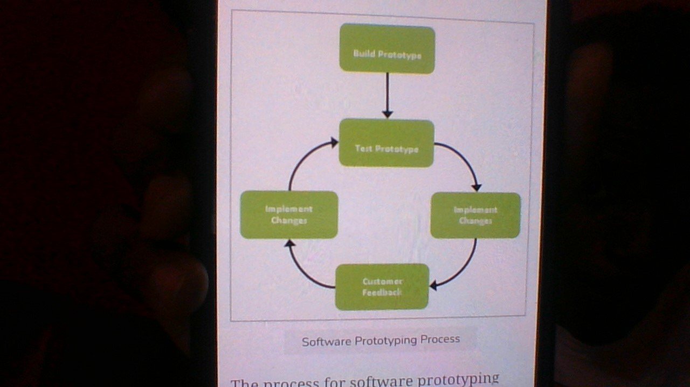

Q6

Explain FOUR major types of software prototyping widely used

* Rapid prototyping – project is expected to be relevant for only a short term
* Evolutionary prototyping- starts with a product that meets the requirements. With time new features / functionalities are continuously being added
* Incremental prototyping - a decision has to be made as to whether the software produced by the cycle will be discarded, or kept as a starting point for the next cycle

Discuss the attributes that a good software engineers should possess

Q7

Explain why evaluation is an important part of any user-centered design process

According to the theory of mental model, everyday reasoning depends on the simulation of events in mental models. Briefly discuss any FIVE assumptions made in the theory.